Have we dumped recycling in the bin?

**By Brooke S, Nusaybah Y, Charlotte C and Jonathan T**

Recycling. What is recycling? Do we even know what recycling is? The process of recycling involves converting waste into reusable materials. But the question we ask ourselves *is do we do this justice?*

We investigated the topic of recycling at our school, Walton-le-Dale, just outside of Preston. We felt that the topic of recycling should be more acknowledged throughout homes throughout schools and throughout the UK. Our teacher Miss Allen said *“I don’t think classroom teachers recycle as well as they could, staff could use separate bins for their classrooms waste, however its money that’s the issue”.*

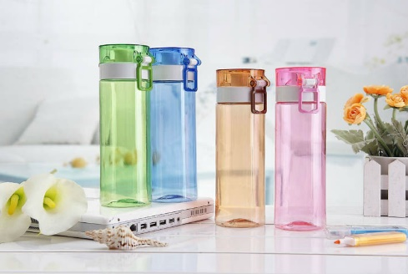This now brings us to another issue in recycling .Money. To transfer rubbish to recycling centres, it costs £120 out of schools budget; this is only 1.5 tonnes. This becomes a problem when schools are trying to recycle cost efficiently as budgets are very low cost.

So how is it we can help this problem? We have come up with several solutions to resolve the issues surrounding recycling; proposing that we get rid of previsions to buy plastic bottles for school dinners. We also like to put forward that the school introduces more water fountains and encourages students to bring in their own reusable water bottles.

The provision of recycling for school

After putting these issues forward and supplying you with solutions, we hope you have taken on board what we have said and our ideas. Recycling is an issue and we feel it needs resolving.